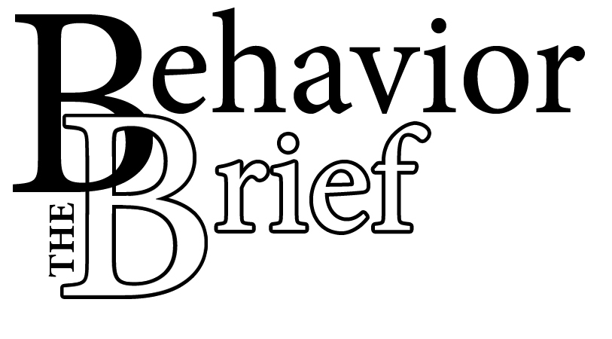
The Behavior Brief is here to give you solid information on behavioral topics. The Behavior Brief is the result of a collaboration among The Watson Institute, Pittsburgh Public Schools and the University of Pittsburgh’s School of Education. We want to support the Pittsburgh Public School District’s priority for safe and welcoming schools.

Each month you will receive an email that contains the newsletter. Inside will be valuable resources based on such issues as bullying, test-taking anxiety, and safe schools.

Is there a particular issue about which you would like more information? We encourage you to send us your suggestions. After all, this newsletter is for you!

We wish you the best of luck in your first weeks of school and remind you to keep checking your email for the next issue of The Behavior Brief!

Welcome Back!
Recent studies tell us that what we say and do during the first weeks of school can make a lasting impression on students and can influence their performance. Consider this example.

Teacher: “This is a very difficult course. I predict that within the next two weeks, most of you will be asking why you have to learn this material.”

Student A: “I guess I won’t be getting any A’s in this class. I am not very good in science anyway.”

Student B: “My older brother says you are fine if you are one of her favorites, but forget it if you aren’t.”
“In sum, the old advice, ‘Don’t smile before Thanksgiving’ is misguided.”

First Impressions Really Do Matter: The Importance of the First Weeks of School
by Allison Gottfried¹
Continued on page 2
We now know that well-meaning teachers who are unaware of the impact of first impressions can send students into a downward spiral with long-term effects on performance². For example, comments such as those made by the science teacher can result in student anxiety and alienation from the classroom. Then students become afraid to ask questions and begin to withdraw from classroom instruction. Ultimately, they lose their sense of self-efficacy and disengage entirely. This disengagement can lead to other problems, too, such as disruptive behavior and absenteeism.

What are the practical implications of this research? First, small gestures and ostensibly insignificant comments have lasting effects on how students perceive their ability to do the work in your class. Secondly, these initial impressions can have long-lasting effects on student performance. In sum, the old advice, “Don’t smile before Thanksgiving” is misguided. Instead, consider some of these suggestions.

- Promote fairness in the classroom by focusing your rules around respecting others. Dn’t be inconsistent in the way you respond to problem behaviors, as this sends a message that you prefer some students to others. Students need and appreciate consistency and are quick to characterize teachers as unfair.

- Show your support and confidence – tell your students you believe in them and that they WILL succeed, learn, and obey the rules! For example, say, “This might seem hard now, but you are going to be able to figure it out because you are a good thinker.” Do not say, “Every year, students have trouble with this chapter.” Instead of saying, “You probably don’t remember much from last year,” say, “It may take a few days for you to get back in gear, but we will be reviewing what you learned last year. So just let me know if you are confused.”

- Establish a consistent routine. Do not change the classroom rules after they have been established.

- Give intrinsic reasons why your students should want to learn the material you are teaching. For example, tell students why your subject is fun, interesting, and how it can be useful. Resist the urge to cite extrinsic reasons as to why your students should want to learn the material you are teaching, such as passing and getting good grades.

“ Initial impressions can have long-lasting effects on student performance.”
- Encourage positive relationships among your students. Support inclusion as opposed to exclusion. For example, encourage students to get to know one another through ice-breaker activities. Recognize students who help others.

- Share personal (but not too personal) information that builds a connection to students. For example, instead of saying, “I guess many of you are worried about taking Algebra I,” say something like, “When I was in middle school, I was intimidated by math so I know how some of you feel.” Instead of saying, “I have a graduate degree in science education,” say something like “I even went back to graduate school in math so that I could learn new strategies for making science more interesting for my students.”

- Bring humor to the classroom and try to lighten up the mood. Avoid sarcasm, as it increases tension. Until students really get to know you, do not tease them or single them out, even with well-intentioned humor. If students tease you, it may be their attempt to connect with you, so try not to take it too seriously or overreact. For example, teenagers may mimic your speech or mannerisms, but it could be because they actually like you!

- Do not focus on your control and authority over the students, as this sets the occasion for resentment and power struggles. For example, do not insist that students look you in the eye when you are correcting them. There is no need continuously to restate that you are in charge. Research shows that doing so could actually undermine your efforts.

- Actively minimize any anxieties your students have about the material. Answer students’ questions without making them feel that their questions are dumb. Watch students’ facial expressions for signs that they are getting confused. Do not structure your messages in such a way that you increase anxiety and fear in your students.

- Take time to celebrate even small accomplishments early in the year, as this will encourage students to keep trying. Do not wait until the mid-term to let students know how they are doing.

¹ Allison Gottfried is a senior in Applied Developmental Psychology working with Dr. Mary Margaret Kerr at the University of Pittsburgh.
² Patrick, H., Turner, J.C., Meyer, D.K. & Midgley, C. How Teachers Establish Psychological Environments During the First Days of School: Associations With Avoidance in Mathematics. Teachers College Record Volume 105 Number 8, 2003, p. 1521-1558. Retrieved from http://www.tcrecord.org

“When I was in middle school, I was intimidated by math so I know how some of you feel.”
‘Looking for a few great resources to learn more about first impressions during the first weeks of school? Check these out!

Barkley, Steve. (2006). The wonder of WOWs: A simple concept brings quality, pizzazz to learning. Kappa Delta Pi Record, 42(4), 3 pp.

Bohn, Catherine M., Roehrig, Alysia D., & Pressley, Michael. (2004). The first days of
school in the classrooms of two more effective and four less effective primary-grades teachers. Elementary School Journal, 104(4), 269.

Emmer, Edmund T. & Gerwels, Mary Claire. (2005). Establishing classroom management for cooperative learning: Three cases. Paper presented at the Annual Meeting of the American Educational Research Association (63rd, Montreal, Canada, April 11-15, 2005). 23 pp.
Hirschstein, Miriam Kathleen. (2000). Community at their heart: Relationships between teachers’ beginning-of-the-year practices and student social perceptions and behaviors. Dissertation Abstracts International, 60(7), 2440.

McCarty, Mary D. (1975). Those first days of school. Education, 95(4), 377-380.

Patrick, H., Turner, J.C., Meyer, D.K., & Midgley, C. (2003). How teachers establish
psychological environments during the first days of school: Associations with avoidance in mathematics. Teachers College Record, 105 (8), 1521-1558.

Watson Institute
Behavior Support for Youth
[WIBSY]

200 Linden Avenue
Sharpsburg, PA 15215
sbarrett@craigacademy.org
Phone:
(412) 781-5438
Fax:
(412) 781-1561

How Can You Learn More?

