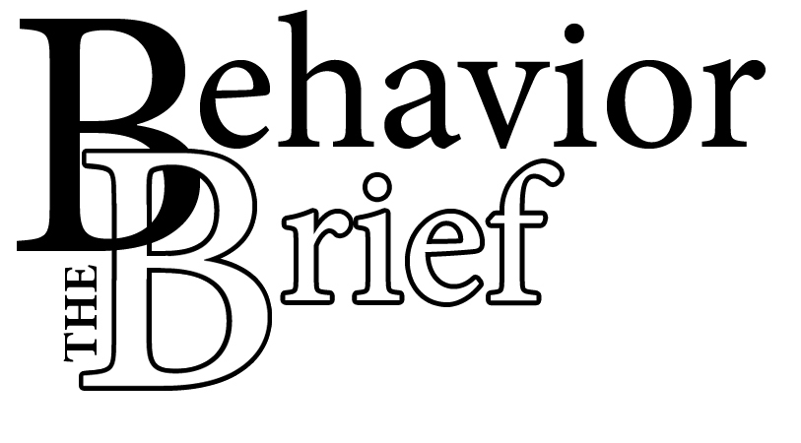
Mrs. Jones: “Tammy, put your iPod away, it’s time to start class now.”

Tammy: “Forget it, I’ll put it away when I feel like it, b****.”

Mrs. Jones: “Don’t ever speak to me like that again, or I’ll send you to the office!”

Tammy: “Well, sh**, send me to the office then!”

The Altercation
WHAT:
Profanity is, quite simply, inappropriate language. Students use profanity to show that they are angry, unhappy, or upset. Unfortunately, profanity is offensive and is an inappropriate way for students to express their feelings. “What does it matter, it’s not a crime.” The answer should be posed as another question, “What GOOD does it do?”

SO WHAT:
Students use profanity for a variety of reasons. Sometimes students swear to gain the attention of their classmates or a teacher. Often, students also use profanity to express strong emotions such as anger, distress, or frustration.
Students imitate what they see. This means that when a students react to a situation inappropriately, they may be mimicking what they have already witnessed at home or in other social settings. Additionally, students may experience increased exposure to profanity as it becomes more prevalent in popular media.

continued on page 2
Students use profanity to show that they are angry, unhappy, or upset.

Profanity in the Classroom

NOW WHAT:
What does this mean for you? Unfortunately, very little research on swearing exists, so we are left with only common-sense strategies. Because swearing, like most language, is developed and maintained in the home or in the community, you may have few options for changing ingrained patterns. Here are a few suggestions for your consideration:

- Do not ignore a student’s profanity. Ignoring profanity communicates to student that swearing is acceptable. Privately acknowledge profanity so that students understand their language is inappropriate. Autonomy-seeking adolescents may react better if you let them know that they are free to choose their language outside of school but that in school, they have to control their profanity.

- React calmly to foul language. Stay in control of your emotions when students use profanity. Remind them that their language is inappropriate and unacceptable. Do not engage an angry student in an argument. Reacting to the swearing will give students the attention they are seeking and will reinforce their impulse to swear.

- Young students may not realize that their language is inappropriate. Speak with the student after inappropriate language has occurred and let them know that their words can hurt others’ feelings. Remind them that certain words that are used outside of school are not appropriate to use in class. It might be necessary to help students find alternative words or ways to express themselves when they are angry.

- Always try to identify the underlying reason for a student’s use of profanity. By doing this, it can allow you to respond more effectively.

- Sometimes you can find a motivation to help a student break the profanity habit. For example, a student may be excited about a new job. In these cases, help the student to self-monitor her profanity so she can see how often she is really using inappropriate language.

¹ Plank, S.B., McDill, E.L., McPartland, J.M., & Jordan, W.J. (2001) Situation and repertoire: Civility, incivility, cursing, and politeness in an urban high school. Teachers College Record, 504(21).
² Shore, K. (2001) Retrieved February 12, 2008 from http://www.education-world.com/a_curr/shore/shore/007.shtml

Stay in control of your emotions.

How Can You Learn More?
Do you need help curbing your students’ foul language? Check out these books for some techniques.

Berenstain, J. & Berenstain, S. (2000) Berenstain Bears and the Big Blooper. Random House Children’s Books.

Shore, K. (2003). Elementary teacher’s discipline solver: A practical a-z guide for managing classroom behavior problems. San Francisco, CA: Jossey-Bass Publishers.

Reichle, J. & Wacker, D.P. (1993). Communicative alternatives to challenging behavior: Integrating functional assessment and intervention strategies. Baltimore, MD: P.H. Brookes Publishing Company.

Sevcik, A., Robbins, B. & Leonard, A. (1997). The deep structure of obscene language. Journal of Curriculum Studies, 29(4), 455-470.

Trice, A.D. & Parker, F.C. (1983). Decreasing adolescent swearing in an instructional setting. Education and Treatment of Children, 6, 29-35.

Zwald, L. & Gresham, F. (1982). Behavioral consultation in a secondary class: Using DRL to decrease negative verbal interactions. School Psychology Review, 11(4), 428-432.

Watson Institute
Behavior Support for Youth
200 Linden Avenue
Sharpsburg, PA 15215
Phone:
412-781-5438
Fax:
412-781-1561

